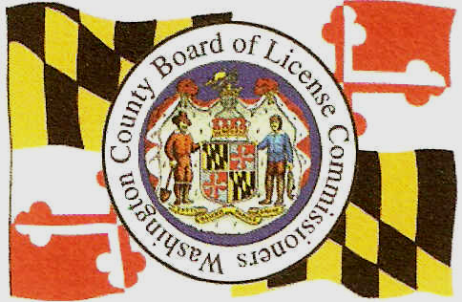
BOARD OF LICENSE COMMISSIONERS
FOR WASHINGTON COUNTY
148 W. Washington Street,
Hagerstown, MD 21740
Phone (301) 797-4591 Fax (301) 797-4599

CATERING EVENT

Name of Caterer:________________________________________________________________

Address of Caterer: _____________________________________________________________

Caterers License #: ______________________________________________________________

EVENT FOR

Name of Person having event: _____________________________________________________

Phone Number of person: ________________________________________________________

Address or Location of event: _____________________________________________________

Type of event: _________________________________________________________________

Date of Catered event: ___________________________________________________________

Time of Catered event: ___________________________________________________________

On-Site Manager for Catered event: ________________________________________________

I hereby certify that this event will be conducted in accordance with Section 6-701 of Article 2B of the Annotated Code of Maryland relating to Caterer’s license authority, all other provisions of Article 2B relating to the sale and distribution of alcoholic beverages, and all applicable regulations promulgated thereunder.

_____________________________________
Signature of Licensee

_____________________________________
Date of Signature

All Catered event forms must be mailed or faxed to our office two (2) weeks prior to the catered event.

